Project Design Phase-II
Data Flow Diagram & User Stories
Date | 18 Feb 2026
Team ID | LTVIP2026TMIDS71823
Project Name | Gemini Pro Financial Decoder: Transforming Complex Data into Actionable Insights
Maximum Marks | 4 Marks

Data Flow Diagram (DFD)
A Data Flow Diagram represents how financial data moves through the Gemini Pro Financial Decoder system. It shows how data is input, processed, stored, and delivered as actionable insights.
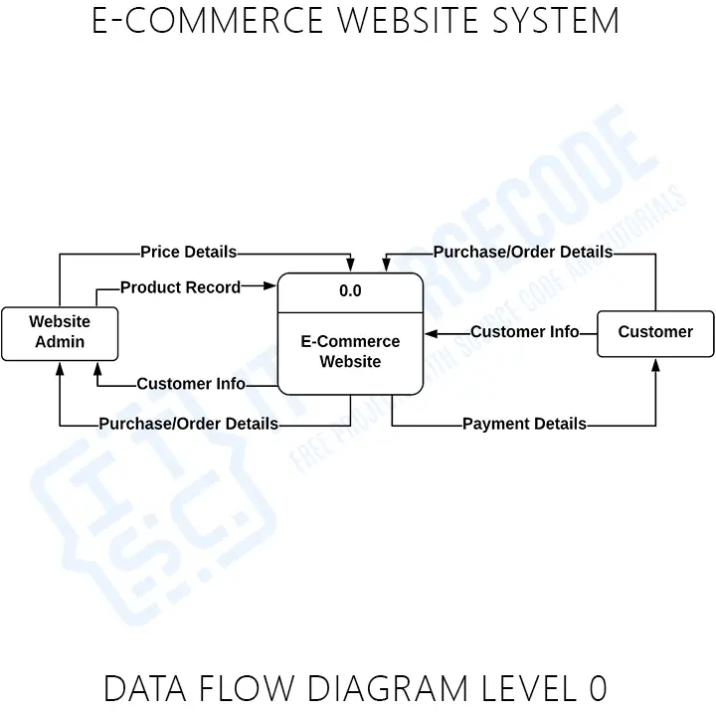

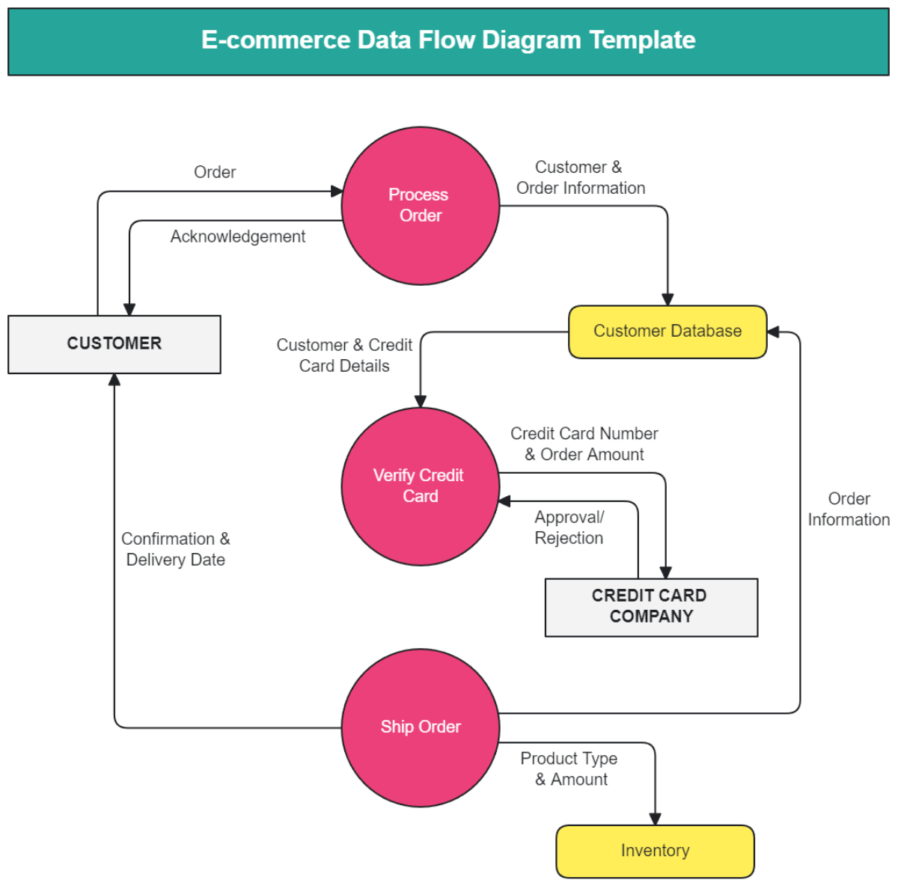

User Stories
User Type | User Role | User Story No | User Story / Task | Acceptance Criteria
Customer (Web User) | Business Owner | USN-1 | As a business owner, I want to upload financial documents so that I can understand my company’s financial health | Upload option available; Supports PDF/Excel/CSV; Upload confirmation shown
Financial Professional | Financial Analyst | USN-2 | As a financial analyst, I want the system to extract key financial metrics so that I can analyze reports faster | Metrics extracted correctly; Displayed in structured format
Investor | Investor | USN-3 | As an investor, I want summarized insights and risk indicators so that I can make informed investment decisions | Summary generated; Risks highlighted clearly
Data Analyst | Finance Manager | USN-4 | As a finance manager, I want visual dashboards so that I can easily track trends and performance | Charts load correctly; Data matches uploaded files
User (General) | Non-Finance User | USN-5 | As a non-finance user, I want explanations in simple language so that I can understand financial terms | Plain-language explanations available
Admin | System Admin | USN-6 | As an administrator, I want all analyses to be logged with timestamps so that audits and tracking are possible | Logs stored with date, time, user ID, and report ID

